**Introduction**

Using the **Feedback Activity**, the Teacher can create a custom survey tool and collect feedback from the students using various question types. The Teacher may set the responses to the feedback anonymous if required. Also, displaying the results to the students is optional. The Teacher can use the feedback for the course and self-evaluation of the Teacher. The opinion of the students can be taken to improve teaching.

**Setting Up of Feedback Activity**

The following are the steps to set up a course's feedback activity.

1. Select the **Turn Editing On** button from the **gear** icon at the top right corner
2. Click the **Add an activity or resource** link and select **feedback** from the Activity Chooser
3. Add a **name** and **description** for the **feedback** and decide whether the description should be **display**ed **on the course page**
4. Under **Availability,**decide the start and end date of the **feedback** activity for the students.The students will get an alert in case the availability option is enabled.
5. **Question and submission settings**

**Record user names**: Decide whether to show the names of students who complete the feedback or maintain **anonymity**.

If **Allow multiple submissions** option is enabled, the students can submit their feedback an unlimited number of times.

**Enable notification of submissions**: If this option is set to 'Yes,' teachers will receive notifications when users submit feedback.

**Auto-number questions**: If set to 'Yes', the questions will be automatically numbered.

1. **Settings related to subsequent actions after submission of feedback**

**Show analysis page:** The summary results in graphical format can be shown to respondents or shown only to teachers.

**Completion message:** This allows the Teacher to present the students with a message after answering the questions (*Usually, 'Thank You'*).

**Link to next activity:** This hyperlink leads the students to another course activity or main course page once they have answered the feedback questions.

1. Maintain the default settings for **the common module**, **Restrict access**, **Activity completion**, **Tags,** and **Competencies.**
2. Select the **Save and Display**button.

**Building Feedback**

1. Upon clicking the **Save and Display** button, a *feedback building window* with five sections (**Overview**, **Edit Questions**, **Templates**, **Analysis,** and **Show responses**) will appear (Figure ).

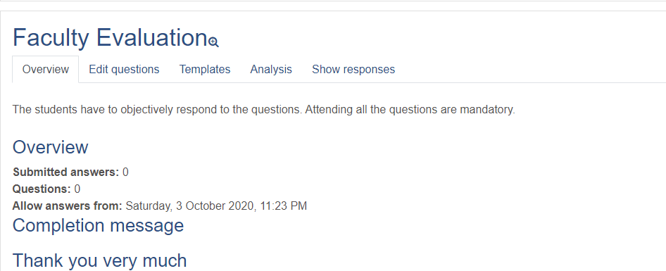

1. The **Overview** section provides an overview of 'Submitted answers,'' Questions,'' Allows answers from, ''Allows answers to' information and c**ompletion message,** thetext the Teacher added to the*completion message* field when setting up the activity.
2. The **Edit Questions** section facilitates adding **five** types of **questions** and **four** types of **page elements** to the Feedback form.

The question types are(a) Longer Text Answer, (b) Multiple Choice, (c) Numeric answer, (d) Multiple Choice (Rated), and (e) Short Text Answer.

The page elements are (a) Page break, (b) Captcha, (c) Information, and (d) Label.

**Longer Text Answer:** This is to create a text box to write a long answer. It is possible to specify the size in rows and columns.

**Short text Answer:** This is to create a text box to write a single-line answer. It is possible to specify the maximum number of characters that can be accepted so that the answer is not too long and does not run over the box's length on the screen.

**Multiple choice: (1) Multiple choice single answer, (2) Multiple choice, multiple answers, and (3) Multiple choice - single answer allowed (drop-down list)**

**Numeric answer: This type of Question** must have a number to answer and specify the acceptable range.

**Captcha:** A test to make sure a real person is filling in the form and not an automatic spamming program of some sort.(*This option is not currently enabled on our system since we do not make course pages available to users who are not logged in*)

**Information** This allows the Teacher to choose to display one of two types of information: the *course* and the *course category* where the feedback is located.

**Label:** The label(*similar to label resource*) allows the Teacher to add arbitrary text between questions allowing for extra explanation or to divide the feedback into sections. (*Normally, the Label option is used only with the dependence questions discussed later*)

1. **Position & Required** Options: These two options are available for most of the Question types.

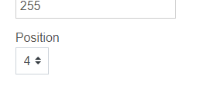

The **Position** number (*available at the end of the question-setting page*) controls the position or the questions' order. Position 1 is the Question nearest to the top of the page. It is possible to rearrange questions by clicking the position up and down arrows on the main add questions screen.

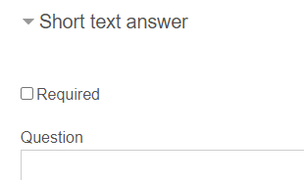

Using the **Required** option, the Teacher can make the Question mandatory. Enabling the *Required* option will prompt the student to answer a question if they are left unanswered.

1. Using the **Template** Section, the Teacher can create and re-use sets of Feedback questions for future use.
2. The **Analysis** facilitates the Analysis of the responses. **Show responses** provide the student-wise response, which can be downloaded in different formats, and the **Show non-respondents** section gives the details of the students who did not respond to the feedback activity.

**Adding questions**

1. Click the **Edit questions** button
2. From the **Add questions** drop-down menu, choose the type of Question

In case the Teacher chose the **Longer text answer** question

1. Tick the **Required** option if the Question is mandatory
2. Enter the **Question** in the column provided
3. Ignore the **label** column
4. Select the **Width** and **Number of lines** of the textbox for answering the Question
5. Decide the **Position** of the Question
6. Click **Save Question**

In case the Teacher chose the **Short text answer** question

1. Tick the **Required** option if the Question is mandatory
2. Enter the **Question** in the column provided
3. Ignore the **label** column
4. Select the **Textfield width** and **Maximum characters accepted** for answering the Question
5. Decide the **Position** of the Question
6. Click **Save Question**

In case the Teacher chose the **Multiple choice / Multiple choice (rated)** question

1. Tick the **Required** option if the Question is mandatory
2. Enter the **Question** in the column provided
3. Ignore the **label** column
4. Select the **Multiple choice type** from the drop-down menu(*Single answer, multiple answers, single answer allowed-drop-down menu*)
5. Decide the **Adjustment** (*vertical/horizontal layout*) in case of *Single answer&, multiple answers* type of question
6. Hide the "Not selected" option, if required ( *in case of a Single answer)*
7. Decide whether to **analyze empty submits**
8. Enter the **Multiple choice values** *one each in a line*
9. Decide the **Position** of the Question
10. Click **Save Question**

In case the Teacher chose the **Numeric question**

1. Tick the **Required** option if the Question is mandatory
2. Enter the **Question** in the column provided
3. Ignore the **label** column
4. Enter **Range from** and **Range to values**
5. Decide the **Position** of the Question
6. Click **Save Question**

**Attending the Feedback by the Students**

1. The students will get a notification regarding the Feedback activity once the questions are setup
2. They can log in and complete the activity

**Analyzing the Feedback**

1. Once the students complete the feedback, the Teacher can log in to the activity page.
2. The **overview** section will provide the Number of the responses received
3. The **Analysis** tab gives a graphical representation of the feedback responses
4. The **Show responses** provide the student-wise response, which can be downloaded in different formats,
5. The **Show non-respondents** section gives the details of the students who did not respond to the feedback activity (Only If the Teacher set the feedback activity as not anonymous ). Put a tick in the checkbox in the Select column and then scroll to the bottom of the screen to compose a message to your non-respondents.

**Setting up of Dependence Questions and Answers**

The Teacher can direct the student to a specific question depending on his answer to a previous multiple-answer question. For example, if the student says 'Yes' to the question "*Should the teacher continue teaching this course*?", she will be directed to another question which is different from if her answers 'No'. Such *dependent questions* can be set by following the steps mentioned below.

1. Under **Edit Questions** section, select the **questions** type
2. Type the Question and give the Question a name in the **Label field** (E.g. *CountinueTeach*)
3. Add multiple choice values (E.g. Yes , No)
4. Click SAVE QUESTIONbutton
5. Go back to Add question option
6. Select **Add a Page Break** from the drop-down menu (*The Page break entered will not be displayed to the Teacher*).
7. Create the **next Question** that depends on the value of **one** answer to the first Question (Eg. In case the answer to the first Question is **YES**, *Why should the teacher continue teaching the course?*  Into the **Dependence item** field, select the first Question (*It will display the name of the Question previously entered under the label*). In the **Dependence, value** field enter the answer that must be selected for this second Question to display.
8. Create the next Question that depends on the value of the second answer to the first Question. Into the **Dependence item** field, select the second Question, and enter the answer that must be selected for this Question to display in the Dependence value field.

**Using Templates**

The Templates tab allows the Teacher to use predefined templates for the feedback. The existing feedback activity can also be saved as a template for later use.

1. To save the existing Feedback activity as a template, click the Template Section and give a name for the template under **Save these questions as a new template**
2. To use an existing template, select the previously saved template from the **Choose drop-down menu**
3. The Teacher can delete templates and export or import questions (in xml format) using the appropriate links at the bottom of the page